**LEVERAGING FACE SECURITY API FOR ENHANCING**

**EDGE COMPUTING SECURITY**

## PHASE PROJECT REPORT

***Submitted by***

**Name: Vasvi N Jain Register No.: 22BTRCC055**

**Name: Vaibhav D Dhonde Register No.: 22BTRCC016**

**Name: Daksh Sharma Register No.: 22BTRCC011**

**Name: Dhrutik Kumar Patel Register No.: 22BTRCC001**

**Name: Rishav Ranjan Register No.: 22BTRCC036**

***Under the guidance of***

**Professor**

**Dr. S. Ravikumar**

***in partial fulfillment of the requirements for the degree of***

#### BACHELOR OF TECHNOLOGY



**DEPARTMENT OF COMPUTER SCIENCE AND ENGINEERING**

**Cyber Security**

## JAIN DEEMED -TO-BE-UNIVERSITY

#### JAKKASANDRA POST, BENGALURU - KANAKAPURA RD, BENGALURU, KARNATAKA, 562112. MARCH 2024



#### DEPARTMENT OF COMPUTER SCIENCE AND ENGINEERING

##### Cyber Security

**BONAFIDE CERTIFICATE**

This is to certify that the project work entitled “**LEVERAGING FACE SECURITY API FOR ENHANCING EDGE COMPUTING SECURITY**” is a bonafide work done by **Students Vasvi N Jain(22BTRCC055), Vaibhav D Dhonde(22BTRCC016), Daksh Sharma(22BTRCC011), Dhrutik Kumar Patel(22BTRCC001), Rishav Ranjan(22BTRCC036)** in partial fulfillment of the requirement, for the award of B.Tech Degree in Computer Science and Engineering by JAIN DEEMED -TO-BE-UNIVERSITY during the academic year 2024-2025.

#### PROJECT GUIDE PROGRAM HEAD

***Submitted for the University Examination held on ……………………………***

**INTERNAL EXAMINER EXTERNAL EXAMINER**

### ACKNOWLEDGEMENT

*It is a great pleasure for us to acknowledge the assistance and support of a large number of individuals who have been responsible for the successful completion of this project work.*

*First, we take this opportunity to express our sincere gratitude to the* ***School of Engineering & Technology, Jain Deemed to be University*** *for providing us with a great opportunity to pursue our Bachelor’s Degree in this institution.*

*In particular we would like to thank* **Dr. G. GEETHA***,* ***Director, School of Engineering & Technology, JAIN (Deemed-to-be University)*** *for their constant encouragement and expert advice.*

*It is a matter of immense pleasure to express our sincere thanks to* **Dr. Sunanda Das***,* ***Head of the Department****,* ***Department of Computer Science and Engineering (Cyber Security)****,* ***JAIN (Deemed- to-be University),*** *for providing the right academic guidance that made our task possible.*

*We would like to thank our guide* **Dr. S. Ravikumar, *Professor, Department of Computer Science and Engineering (Cyber Security), JAIN (Deemed-to-be University)****, for sparing his/her valuable time to extend help in every step of our project work, which paved the way for smooth progress and fruitful culmination of the project.*

*We are also grateful to our family and friends who provided us with every requirement throughout the course.*

*We would like to thank one and all who directly or indirectly helped us in completing the Project centric learning successfully.*

### Signature of Students

**ABSTRACT**

This paper examines the utilization of a Face Security API as a means to enhance security in edge computing environments. With the proliferation of edge computing and the associated challenges of securing distributed systems, incorporating facial recognition technology becomes crucial. By harnessing the capabilities of a Face Security API, this research investigates the potential advantages and obstacles of implementing such mechanisms to safeguard edge computing systems against unauthorized access, data breaches, and malicious activities. The study explores the functionality and limitations of the Face Security API, evaluates its effectiveness within edge computing scenarios, and addresses ethical considerations. Through a comprehensive analysis of existing literature and practical case studies, this research aims to provide valuable insights and recommendations on effectively leveraging the Face Security API to bolster security in edge computing architectures**.**

### *Keywords: Edge computing, Performance, Face Security API Security, Scalability, Distributed systems, Authentication, Cost, Facial recognition, Privacy, Unauthorized access, IoT, Data breaches, Malicious activities, Ethical considerations, Case studies*

### LIST OF TABLES

#### TABLE NO. NAME OF THE TABLE PAGE NO.

##### Recent Research on Facial Recognition and Security in Edge Computing 20-21

**LIST OF FIGURES**

|  |  |  |
| --- | --- | --- |
| **FIGURE NO** | **FIGURE NAME** | **PAGE NO** |
| 01  02  03  04  05  06  07  08  09  10  11  12  13  14  15  16  17 | *Face Recognition Capture System*  *Face Security System Problems*  *Face Security Utilization*  *Face Security System in Edge Computing Working*  *API Software and Hardware use*  *Face Security System API working*  *Existing System API*  *Limitation Survey of Existing System*  *Proposed System API Base*  *Architecture*  *Dataset in Layers in Proposed System*  *Implementation Demo*  *Sequence Diagram*  *Data Flow Diagram*  *Desired Output*  *Security Strategies*  *Future Scope* | 09  11  12  14  16  19  23  24  27  32  33  35  37  38  43  43  49 |

|  |  |
| --- | --- |
| **TABLE OF CONTENTS** | |
|  | Page No. |
| CERTIFICATE | 01 |
| DECLARATION | 02 |
| ACKNOWLEDGEMENT | 0*3* |
| ABSTRACT | 04 |
| CHAPTER 1: INTRODUCTION |  |
| 1.1. Overview | 08 |
| 1.2. Problem Definition | 10 |
| 1.3. Objectives | 12 |
| 1.4. Methodology | 13 |
| 1.5. Hardware and Software tools used | 15 |
| CHAPTER 2: LITERATURE SURVEY |  |
| 2.1. Related Work | 18 |
| 2.2. Existing System | 22 |
| 2.3. Limitation of Existing system | 24 |
| 2.4. Proposed system | 26 |
| CHAPTER 3: METHODOLOGY |  |
| 3.1. Dataset | 29 |
| 3.2. Architecture | 32 |
| 3.3. Sequence Diagram | 37 |
| 3.4. Data Flow Diagram | 38 |
| CHAPTER 4: TOOL DESCRIPTION |  |
| 4.1. Hardware Requirement | 39 |
| 4.2. Software Requirement | 41 |
| CHAPTER 5: RESULT AND ANALYSIS |  |
| 5.1. Result discussion | 42 |
| 5.2. Comparison With Previous Studies | 44 |
| 5.3. Analysis | 46 |
| CHAPTER 6: CONCLUSION AND FUTURE SCOPE |  |
| 6.1. Future Scope | 47 |
| 6.2. Conclusion | 50 |
| REFERENCES | 51 |

**CHAPTER 1: INTRODUCTION**

* 1. **OVERVIEW**

The utilization of edge computing has surged in recent years, bringing computation and data storage closer to the source of data generation. However, this distributed nature of edge computing also poses significant security challenges that demand robust mechanisms for safeguarding sensitive information and ensuring system integrity. This paper delves into the utilization of a Face Security API as a means to enhance security within edge computing environments. The integration of facial recognition technology becomes crucial in addressing the challenges associated with securing distributed systems. By leveraging the capabilities of a Face Security API, this research investigates the potential benefits and obstacles of implementing such mechanisms to protect edge computing systems against unauthorized access, data breaches, and malicious activities.

The study encompasses a comprehensive analysis of the functionality and limitations of the Face Security API, evaluating its effectiveness in diverse edge computing scenarios. It also addresses the ethical considerations surrounding the use of facial recognition technology in edge computing environments, particularly in terms of privacy and potential misuse of personal information. The paper draws insights from existing literature and practical case studies, aiming to provide valuable recommendations on effectively harnessing the Face Security API to strengthen security in edge computing architectures.

The integration of a Face Security API offers numerous advantages for enhancing edge computing security. By adding facial recognition as an authentication layer, it enables the system to mitigate risks associated with unauthorized access, including data breaches and malicious activities. Real-time detection of security breaches becomes possible through facial feature analysis and comparison with an authorized user database. Additionally, the Face Security API allows for user behavior analysis, enabling dynamic access control based on individual identification. These benefits enhance the security posture of edge computing, promoting prompt threat detection and proactive response.

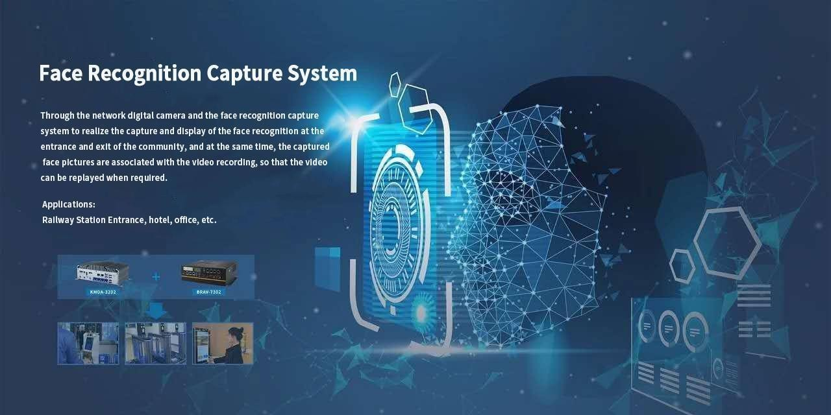

*fig: 01 – Face Recognition Capture System*

However, challenges must be addressed when integrating a Face Security API into edge computing environments. Privacy concerns and ethical considerations are critical factors that require attention. The paper emphasizes the importance of implementing appropriate data protection measures, complying with privacy regulations, and maintaining transparent communication with users regarding the collection and usage of facial data. Furthermore, performance and scalability aspects of the Face Security API need evaluation to ensure its feasibility within resource-constrained edge devices. The study emphasizes the need to balance accuracy, resource consumption, and real-time processing requirements.

In conclusion, this research sheds light on the potential benefits and challenges associated with incorporating a Face Security API into edge computing environments. By offering robust authentication, real-time threat detection, and dynamic access control, facial recognition technology strengthens the security of edge computing systems. Through careful consideration of privacy concerns, ethical considerations, and performance implications, the effective utilization of the Face Security API can contribute to secure and reliable edge computing ecosystems. The insights and recommendations provided in this paper aim to advance the understanding and implementation of facial recognition-based security mechanisms in edge computing architectures.

# PROBLEM DEFINITION

### Security Challenges and Solutions in Edge Computing: Safeguarding Distributed Environments

The proliferation of edge computing has introduced unique security challenges due to the distributed nature of the systems involved. Securing sensitive information and ensuring the integrity of edge computing environments is crucial, given the increasing prevalence of unauthorized access, data breaches, and malicious activities. To address these challenges, there is a need to explore effective security mechanisms specifically designed for edge computing.

* + 1. **Leveraging Facial Recognition with Face Security API: Addressing Implementation Challenges in Edge Computing**

One potential solution is the integration of a Face Security API, leveraging facial recognition technology to enhance security within edge computing architectures. However, several problems must be addressed to effectively implement this solution. Firstly, the functionality and limitations of the Face Security API need to be thoroughly examined to assess its feasibility and suitability for edge computing environments. Understanding the capabilities and potential drawbacks of the API is crucial in determining its effectiveness in safeguarding edge computing systems

### Ethical Considerations in Edge Computing: Balancing Enhanced Security with Privacy and Facial Recognition Technology

Ethical considerations also arise when employing facial recognition technology in edge computing. Privacy concerns regarding the collection and usage of facial data must be carefully addressed to ensure compliance with regulations and maintain user trust. It is essential to strike a balance between the benefits of enhanced security and the ethical implications associated with the use of facial recognition technology.



*fig: 02 – Face Security System Problems*

### Optimizing Performance and Scalability: Integrating Face Security API in Edge Computing Environments

Furthermore, performance and scalability are significant challenges when integrating the Face Security API into edge computing environments. Edge devices typically have limited computational resources and bandwidth. Therefore, it is essential to evaluate the API's performance, considering

factors such as processing speed, accuracy, and resource consumption. The solution should be optimized to meet the real-time processing requirements of edge computing while minimizing the impact on system performance.

### Enhancing Security in Edge Computing: Exploring Face Security API Advantages and Challenges

The problem at hand is to determine the potential advantages and obstacles of leveraging a Face Security API for enhancing security in edge computing environments. This includes evaluating the functionality and limitations of the API, addressing ethical concerns, and assessing its performance within edge computing scenarios. By addressing these challenges, the aim is to provide insights and recommendations for effectively implementing facial recognition-based security mechanisms, ultimately bolstering security in edge computing architectures and ensuring the integrity of sensitive data.

# OBJECTIVES

The objective of this research is to explore the utilization of a Face Security API as a means to enhance security in edge computing environments. The

primary goals are as follows:

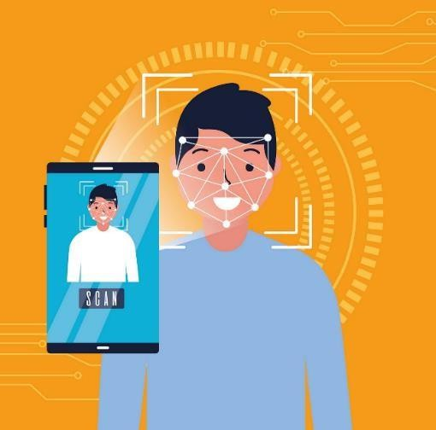

*fig: 03 –Face Security Utilization*

1. To investigate the potential advantages and obstacles of integrating facial recognition technology into edge computing architectures to safeguard against unauthorized access, data breaches, and malicious activities.
2. To evaluate the functionality and limitations of the Face Security API within diverse edge computing scenarios, considering factors such as authentication, real-time threat detection, and dynamic access control.
3. To address ethical considerations surrounding the use of facial recognition technology in edge computing, particularly in terms of privacy, consent, and the responsible handling of personal information.
4. To provide insights and recommendations based on a comprehensive analysis of existing literature and practical case studies, aimed at effectively leveraging the Face Security API to bolster security in edge computing architectures.

# METHODOLOGY

To achieve the objectives outlined in the abstract, the following enhanced methodology is proposed:

1. **Case Study Analysis:** This step involves identifying relevant case studies and practical implementations where facial recognition technology has been applied in edge computing scenarios. These case studies will be thoroughly analyzed to assess the effectiveness of the Face Security API in real-world edge computing environments. By evaluating the outcomes, challenges encountered, and lessons learned from these implementations, we can gain valuable insights into the practical applicability and potential improvements of the API.
2. **Functionality and Limitations Evaluation:** In this phase, we will conduct a comprehensive examination of the Face Security API's functionality and limitations through rigorous experimental analysis and testing. This evaluation will focus on assessing the API's capabilities in terms of authentication, real-time threat detection, and dynamic access control within edge computing architectures. By carefully determining the strengths and weaknesses of the API, we can better understand its potential in addressing security challenges specific to edge computing scenarios.
3. **Ethical Considerations:** The integration of facial recognition technology in edge computing raises important ethical implications that must be thoroughly investigated. We will delve into privacy concerns, consent requirements, and the potential misuse of personal information. Additionally, we will explore strategies for ensuring compliance with privacy regulations, maintaining transparency, and protecting user rights. Ethical considerations are critical in shaping the responsible implementation of facial recognition technology in edge computing environments.
4. **Performance Evaluation:** This stage involves conducting in-depth performance evaluations of the Face Security API in edge computing scenarios. We will measure factors such as processing speed, accuracy, and resource consumption to determine the API's impact on the performance and scalability of edge devices. The goal is to strike the right balance between accuracy and resource constraints, ensuring that the solution meets the real-time processing requirements of edge computing systems while maintaining satisfactory security levels.
5. **Insights and Recommendations:** Drawing from the literature review, case studies, functionality evaluation, ethical considerations, and performance evaluation, this final step will provide valuable insights and recommendations for effectively leveraging the Face Security API to enhance security in edge computing architectures. These recommendations will be tailored to address the identified challenges and maximize the benefits of facial recognition technology while safeguarding privacy and maintaining system performance.

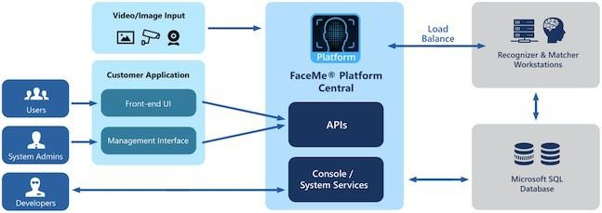

*fig: 04 – Face Security System in Edge Computing Working*

By employing a comprehensive approach that combines literature review, case study analysis, experimental evaluations, and ethical considerations, this research aims to offer practical and well-rounded insights into the integration of a Face Security API in edge computing environments. Ultimately, the findings and recommendations from this study will contribute to enhancing the security posture of distributed edge systems, providing a more secure and responsible implementation of facial recognition-based security mechanisms in the context of edge computing.

# HARDWARE AND SOFTWARE REQUIREMENTS

### Hardware Requirements:

### Edge Computing Devices:

The research requires access to edge computing devices that support the execution of facial recognition algorithms. These devices should possess the necessary computational capabilities to run the Face Security API efficiently.

### Cameras:

High-quality cameras capable of capturing clear and detailed facial images are essential for accurate facial recognition. The hardware should include cameras that can be integrated with the edge computing devices or connected externally.

### Storage:

Sufficient storage capacity is needed to store the facial recognition models, authorized user databases, and captured facial images for training and inference purposes.

### Processing Power:

Edge computing devices should have adequate processing power to handle the computational requirements of facial recognition algorithms, including real-time image processing, feature extraction, and matching against the authorized user database.

### Network Infrastructure:

A stable and reliable network connection is necessary for communication between the edge computing devices and any remote servers or cloud services involved in the Face Security API implementation. The network infrastructure should support data transmission with low latency and sufficient bandwidth.

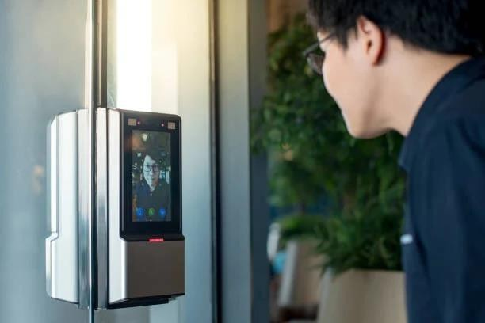

*fig: 05 – API Software and Hardware Use*

### Software Requirements:

### Operating System:

The edge computing devices should have a compatible operating system that supports the execution of the Face Security API and associated software components.

### Facial Recognition Software:

The Face Security API, along with any required software libraries or frameworks, should be installed and configured on the edge computing devices. This may include popular facial recognition software packages such as OpenCV, Dlib, or specialized APIs provided by facial recognition technology providers.

### Programming Environment:

A programming environment, such as Python or a similar language, is required to develop, implement, and integrate the necessary software components. It should include relevant libraries and tools for data preprocessing, model training, and inference.

### Database Management System:

A database management system is needed to store and manage the authorized user database, which may contain facial feature embeddings or relevant metadata for identification and verification purposes.

### Network Communication Protocols:

Software components responsible for network communication, such as APIs or protocols like HTTP or WebSocket, should be supported by the edge computing devices to facilitate interaction with remote servers or cloud services involved in the Face Security API implementation.

### Privacy and Security Tools:

To address privacy concerns and ensure compliance with regulations, appropriate privacy and security tools should be incorporated. This may include encryption algorithms, anonymization techniques, and secure data transmission protocols. It is important to note that the specific hardware and software requirements may vary depending on the chosen Face Security API, edge computing devices, and facial recognition software packages. It is recommended to consult the documentation and guidelines provided by the respective hardware and software vendors to ensure compatibility and optimal performance.

# CHAPTER 2: LITERATURE SURVEY

#### RELATED WORKS

Facial expression recognition has become a significant area of research in the fields of artificial intelligence, computer vision, and human-computer interaction. The recognition process involves three main steps: image preprocessing, feature extraction, and facial expression classification [2]. Traditional methods for facial expression recognition relied on manually designed feature extraction algorithms, such as active appearance model algorithms and algorithms based on local features like Garbor wavelet,[1] Weber Local Descriptor (WLD), Local Binary Pattern (LBP), and multi-feature fusion. However, these methods faced challenges in maintaining robustness to image scale, lighting conditions, and often suffered from information loss in the original images.

To overcome the limitations of manual feature extraction, deep neural networks have emerged as a powerful tool for automatically learning facial expression features, achieving high recognition rates.[2] However, as the number of layers and parameters in neural networks increased, they tended to overfit the data, particularly in cases where the facial expression datasets were small,[3] imbalanced, or had high sample similarity.

Data augmentation, an essential technique for addressing sample shortages and imbalances, was explored to expand training samples. Traditional methods like rotation and crop augmentation were [1] employed but were found to generate duplicate and similar samples, failing to adequately address the problem of high sample similarity.

In contrast, Generative Adversarial Networks (GANs) were introduced to facial expression data augmentation, offering the potential to generate facial expression images with a similar distribution to the target dataset. GANs successfully addressed the [2] issue of high sample similarity but still lacked constraints, resulting in uneven quality of generated images.

To tackle the challenges posed by imbalanced facial expression samples, especially the scarcity of certain expressions like disgust and sadness, the paper under review introduced Cycle GAN for data augmentation. Cycle GAN allowed mapping of neutral expressions to multiple

categories [4] of expressions, such as happy, sad, and surprised. However, Cycle GAN required multiple training iterations for one-to-many mappings, which incurred significant time costs.[3]

To improve upon Cycle GAN, the authors proposed a Constrained Circular Consensus Generative Adversarial Network (GAN) for facial expression recognition. This network introduced class constraint conditions and gradient penalty rules, enabling one-to-many mapping transformations in a single model. By reducing the model training [2] overhead and ensuring higher quality generated images, the proposed method addressed the challenges of imbalanced facial expression samples effectively.

Overall, the literature survey has shown that the application of deep convolutional neural networks and GANs, especially the proposed Constrained Circular Consensus GAN,[3] has significantly advanced the field of facial expression recognition. These approaches have demonstrated promising results in overcoming the limitations of traditional feature extraction methods and handling imbalanced and [1] limited facial expression datasets. However, further research and experiments may be required to assess the generalizability and robustness of these methods across diverse datasets and real-world scenarios [2].

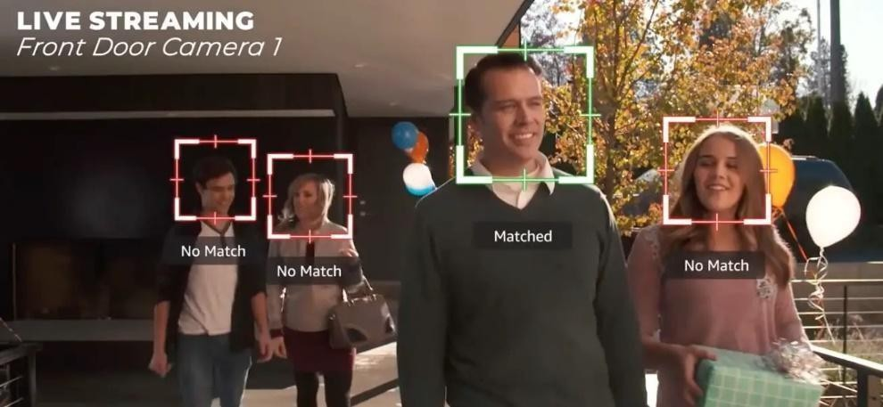

*fig: 06 – Face Security System API Working*

|  |  |  |  |
| --- | --- | --- | --- |
| **Sr. No.** | **Author** | **Title** | **Result** |
| 1. | By Matt R. Cole | Edge Computing for Facial Recognition & Emotion Detection (2021) | Edge Computing, especially when it comes to facial and emotional recognition, is an incredibly lucrative field that may boom in the next five to ten years |
| 2. | By Hang Xing | A Facial Expression Recognition Method Using Deep Convolutional Neural Networks Based, Edge Computing (2022) | The imbalanced number and the high similarity of samples in expression database. |
| 3. | Yuan Xie  Luchang Ding | An Optimized Face Recognition for Edge Computing (2014) | Experimental results show that our optimized face recognition has successfully raised its processing speed for over 60 times, and is able to perform a real-time face recognition at 7.031 FPS with a high accuracy of 93%. |
| 4. | Kevin Putra  Dirganto ro  Jae min Lee  Dong- Seong Kim | Generative Adversarial Networks Based on Edge Computing With Blockchain Architecture for Security System (2020) | This paper proposes a face recognition for security system based on artificial intelligence and edge computing with a limited dataset. |
| 5. | Yuling Chen | A Privacy Protection Scheme for Facial Recognition and Resolution Based, published on Edge Computing (2022) | In this paper, we focused on the privacy security of facial recognition and resolution framework based on edge computing. |

|  |  |  |  |
| --- | --- | --- | --- |
| **Sr. No.** | **Author** | * + **Title** | **Result** |
| 6. | Theo Lynn  John G Mooney | Opportunities and Challenges in Fog and Edge Computing (2020) | Cloud, Membership inference attacks seek to infer membership of individual training instances of a model to which an adversary has black-box access through a machine learning-as-a-service API. |
| *7.* | Manik Rakhra  Dalwindra Singh | Face Recognition with Smart Security System (2022) | In this research, we provide an innovative approach to utilizing social media and human interaction to collect data for the purpose of training a security system. |
| *8.* | Aisha Bazama  Fawzia mansur  Nura Alsharef | Security System by Face Recognition (2021) | Authentication is one of the major challenges of the information systems era. From among other Recognizing the human face is one of the known techniques that can be user authentication. |
| *9.* | Ghula M Muhamm ad  M.Shami M Hossain | Emotion Recognition for Cognitive Edge Computing Using Deep Learning (2021) | The growing use of the Internet of Things (IoT) has increased the volume of data to be processed by manifolds |
| 10. | Mr. Gopala Krishna Sriram | Edge computing vs cloud computing an overview of big data challenges and opportunities for large enterprises (2022) | There are a variety of security concerns around cloud computing infrastructure technology. Some of these include infrastructure security against threats, data privacy, integrity, and infrastructure stability |
| 11. | Heejae Han | Smart security system based on edge computing and face recognition (2023) | Physical security is one of the most basic human needs. People care about it for various reasons; for the safety and security of personnel, to protect private assets, to prevent crime, and so forth. |
| 12. | Gagande ep Kaur  Ranbir Singh Batth | Edge Computing: Classification, Applications, and Challenges (2021) | Edge computing is a relatively recent phenomenon in the computing world, which takes cloud computing services closer to the end user and is distinguished by fast processing and application response time |

# EXISTING SYSTEM

# **Security Concerns:**

The lack of advanced security measures at the edge makes the existing system vulnerable to cyber threats, spoofing attacks, and unauthorized access to sensitive data [7]. Ensuring secure and reliable facial recognition is essential for applications that require stringent access control.

**Centralized Cloud-based Solutions:**

The conventional approach to facial recognition in edge computing relies [5] on transmitting raw biometric data to centralized cloud servers for processing. This introduces potential privacy risks as sensitive data is exposed during transmission, and it may lead to higher latency due to data round-trip [7] times between edge devices and the cloud.

### Latency and Real-time Constraints:

Certain edge computing applications demand real-time processing, such as surveillance systems and access control in secure facilities.[4] The existing system may not meet these requirements, compromising the overall effectiveness of security measures.

### Data Privacy:

The transmission of raw biometric data to the cloud raises concerns about user privacy and compliance with data protection regulations. In the existing system, it is challenging to guarantee full [4] data privacy during transmission and processing.

### Traditional Edge Computing Environment:

In the existing system, edge computing is primarily focused on optimizing data processing and reducing communication overhead by decentralizing computation.[7] However, the absence of robust facial recognition capabilities at the edge leads to certain limitations, such as slower response times and reliance on cloud servers for authentication tasks.

### Scalability Challenges:

The current system faces scalability challenges when dealing with a large number [8] of edges

devices requiring real-time facial recognition. Centralized cloud-based solutions may struggle to handle the increased workload, resulting in performance bottlenecks.

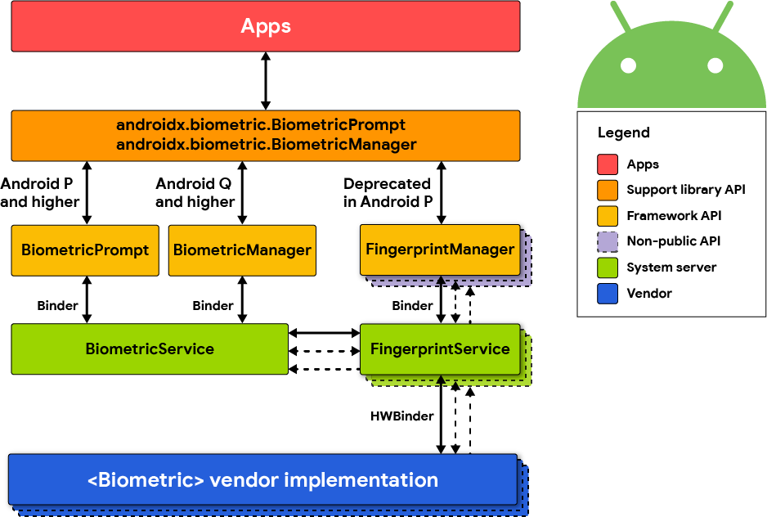

*fig: 07– Existing System API*

# LIMITATIONS OF EXISTING SYSTEM

### Vulnerable Edge Devices:

Edge computing devices, such as IoT sensors, smart cameras, and edge servers, are typically designed with limited computing resources to operate efficiently [5] in edge environments. However, these resource constraints often come at the expense of robust security features. As a result, edge devices may lack the necessary processing power and memory to implement advanced security measures, leaving them vulnerable to various cyber threats.

### Data Tampering:

Since edge devices handle critical data close to the data source, attackers can attempt to tamper with the data to inject malicious code or false information. This can lead to inaccurate processing or erroneous decisions based on compromised data.

### Unauthorized Access:

Weak or default credentials and insufficient access controls on edge devices can allow unauthorized individuals to gain access to sensitive data or manipulate [6] the device's functionality, leading to potential data breaches or operational disruptions.

### DDoS Attack:

Due to their limited capacity to handle large volumes of incoming traffic, edge devices can easily become overwhelmed by Distributed Denial of Service [8] (DDoS) attacks, rendering them non-functional and affecting the entire edge network's performance.

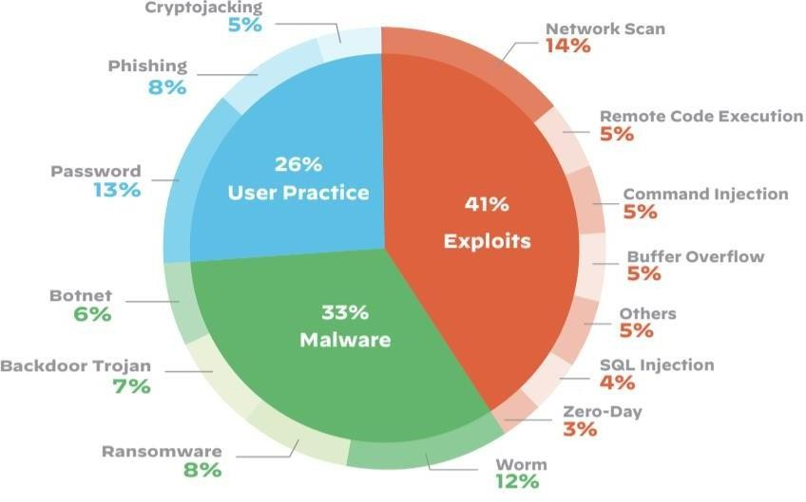

*fig: 08– Limitation Survey of Existing System*

### Addressing the Limitations with Face Security API:

##### 

##### Localized Authentication:

By implementing facial recognition at the edge, authentication can be performed locally, reducing dependency on centralized systems and mitigating the risk of server-based attacks.

### Encrypted Communication:

Utilizing encrypted communication channels ensures the secure transmission of data between edge devices and cloud servers, safeguarding against interception and tampering.

### Continuous Monitoring:

Face Security API can provide continuous monitoring and instant alerts in case [5] of unauthorized access attempts, enhancing the overall security posture of the edge network.

### Network Communication:

Edge devices communicate with the central cloud to transfer data and receive instructions.[7] However, data transmission over potentially untrusted networks can pose security risks if not adequately protected.

### Data Interception:

Without proper encryption and security measures, data transmitted between edge [5] devices and the central cloud can be intercepted by malicious actors, leading to unauthorized access to sensitive information.

### Data Tampering:

Attackers can alter data during transmission, compromising the integrity of the data and potentially leading to incorrect decisions or actions based on manipulated information.

### Scalability:

As edge computing systems expand to accommodate a growing number of edges [6] devices to support various applications, managing and securing a large and diverse network becomes increasingly challenging.

### Management Overhead:

If each edge device requires individual authentication and access control configuration, the administrative burden can become overwhelming, leading to errors and misconfigurations.

### Resource Constraints:

Scaling up the security infrastructure to handle a large number of edge devices may [7] require additional resources, which could strain the already resource-constrained edge environment.

**Complexity:**

As the edge network grows, maintaining a consistent and robust security posture across all devices becomes more complex and prone to inconsistencies.

# PROPOSED SYSTEM

The proposed system aims to bolster edge computing security through the implementation of facial recognition-based authentication and encrypted communication mechanisms. This chapter outlines the key components of the system and elaborates on its advantages while addressing potential implementation challenges.

### Localized Biometric Authentication

The cornerstone of the proposed system is the integration of the Face Security API into edge devices, enabling facial recognition-based authentication for users attempting to access edge devices or applications [3]. By leveraging localized biometric authentication, the system minimizes reliance on centralized authentication servers, thereby mitigating the risk of a single point of failure and reducing potential attacks on the authentication infrastructure. This approach significantly enhances the security of edge devices [6], as facial recognition adds an additional layer of defence, making it difficult for unauthorized individuals to gain access.

### Encrypted Communication

To ensure the confidentiality and integrity of data transmitted between edge devices and the central cloud, the proposed system implements encrypted communication channels utilizing industry-standard protocols such as Secure Socket Layer (SSL) or Transport Layer Security (TLS). Through encryption, sensitive information exchanged between edge devices and the cloud is protected from interception and tampering during transit [5]. The use of encrypted communication safeguards against data breaches, ensuring that only authorized parties can access and interpret the transmitted data.

### Continuous Monitoring and Alerts

The Face Security API enables continuous monitoring of authentication attempts, enabling the system to proactively detect suspicious or unauthorized access attempts. In such instances, instant alerts are generated, promptly notifying administrators or security personnel [5]. This real-time threat detection capability enhances the system's ability to identify potential security breaches swiftly, allowing for immediate responses to mitigate risks and prevent potential data breaches.

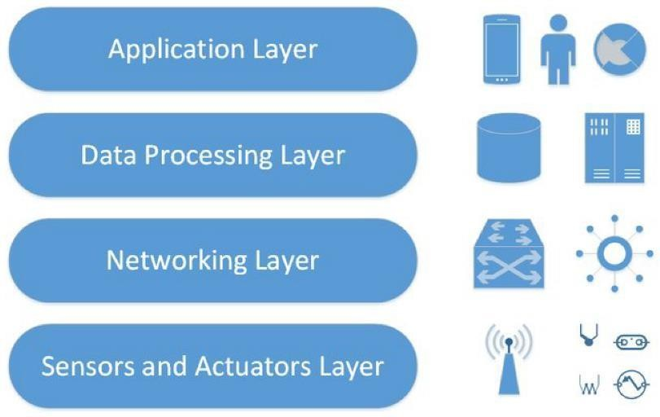

*fig: 09– Proposed System API Base*

### Advantages of the Proposed System:

1. **Enhanced Authentication Security**: The localized facial recognition-based authentication significantly improves the security of edge devices,[11] reducing the likelihood of unauthorized access and potential data breaches resulting from weak or compromised passwords.
2. **Decentralized Authentication**: The proposed system reduces dependency on centralized authentication servers, mitigating the risk of a single point of failure and enhancing [11] the system's resilience against attacks on authentication infrastructure.
3. **Secure Data Transmission:** The use of encrypted communication channels ensures data integrity and confidentiality during transmission, protecting sensitive information from interception and tampering.
4. **Real-time Threat Detection**: Continuous monitoring and instant alerts enable swift identification of suspicious activities, [10] enabling timely responses to potential security threats.

### Implementation Challenges:

**Resource Constraints:** Integrating the Face Security API on resource-constrained [11] edge devices may require careful optimization to ensure efficient performance without significant resource overhead.

**Privacy Concerns**: Biometric data, such as facial images, must be handled with utmost care to address privacy concerns and comply with data protection regulations.

**Compatibility:** The proposed system should be compatible with various edge devices and architectures to ensure seamless integration into existing edge computing environments.[8]

## 

## CHAPTER - 3: METHODOLOGY

* 1. **: DATASET**

##### Define the dataset requirements for training and testing the Face Security API:

In this phase, it's crucial to outline the specific characteristics and composition of the dataset needed for training and testing the Face Security API. Consider the following aspects:

* + **Diversity:** Ensure diversity in the dataset to account for variations in facial features, lighting conditions, and backgrounds. This diversity is essential to train a robust facial recognition model capable of handling real-world scenarios.
  + **Size of the Dataset:** Determine the size of the dataset needed for effective training. The dataset size may influence the model's accuracy and generalization to different scenarios. A sufficient number of images are necessary to train the face recognition model effectively. The exact number depends on the complexity of the model and the desired level of accuracy.
  + **Quality:** The images should be of high quality, with clear facial features and minimal occlusions or distortions. Low-quality images can hinder the training process and lead to inaccurate recognition.
  + **Varied Poses and Lighting:** The dataset should include images with faces in different poses, such as frontal, profile, and semi-profile views, as well as under varying lighting conditions, including bright, dim, and natural lighting.
  + **Image Format:** The images should be stored in a compatible format, such as JPEG, PNG, or TIFF, and should be of a consistent size and resolution.
  + **Annotations:** If applicable, define the annotation requirements for the dataset. Annotations could include bounding boxes around faces, identity labels, or any other relevant information.
  + **Dataset:** Data sets play a crucial role in training and evaluating face recognition algorithms. The quality and diversity of the data set directly impact the accuracy and performance of the algorithm. Some of the commonly used face recognition datasets include:
    - CelebA: A large-scale dataset of celebrity images with over 200,000 face images and 10,177 identities.
    - MS-Celeb-1M: A massive dataset containing over 10 million faces of 100,000 people.
    - VGG Face2: A dataset of over 3,000 face images with high-quality annotations for facial landmarks.
    - Programming language used for making facial recognition is Pyhton, Java, C/C++, Matlab.
  + **Algorithm:** Various algorithms are employed for face recognition, each with its strengths and limitations. Some of the commonly used algorithms include:
    - FaceNet: A deep convolutional neural network (CNN) architecture that has achieved state-of-the-art performance in face recognition.
    - OpenFace: A face recognition toolkit based on a combination of CNNs and deep learning techniques.
    - Eigenfaces: Eigenfaces are another dimensionality reduction technique that represents faces as a combination of eigenfaces, which are the principal components of a training set of faces. They are similar to Fisher Faces but may not be as robust to variations in lighting and pose.
    - Deep Convolutional Neural Networks (CNNs): CNNs are the most prevalent and successful algorithms for face recognition, achieving state-of-the-art performance. They extract hierarchical features from facial images, enabling accurate recognition despite variations in appearance.

1. **Specify the ethical considerations regarding data collection and usage:**

Ethical considerations are paramount, especially when dealing with facial data. Address the following:

* **Informed Consent:** The procedures for obtaining informed consent from individuals whose facial data is included in the dataset. Clearly communicate the purpose of data collection and how the data will be used.
* **Privacy Protection:** Facial recognition involves the collection and analysis of highly sensitive biometric data, which raises significant privacy concerns. The mass collection of facial data can be used to create detailed profiles of individuals, revealing personal information about their movements, associations, and even emotions. This level of surveillance poses a threat to individual autonomy and the right to privacy.
  + **Surveillance and Mass Monitoring:** The widespread deployment of facial recognition systems in public spaces, such as transportation hubs, workplaces, and even residential areas, raises concerns about mass surveillance and the erosion of individual freedom. Constant monitoring and tracking of individuals without their knowledge or consent can create a chilling effect on freedom of expression and movement.
  + **Bias and Discrimination**: Facial recognition algorithms have been shown to exhibit biases, particularly in terms of race, gender, and age. These biases can lead to discriminatory outcomes, reinforcing existing societal inequalities. For instance, studies have shown that facial recognition systems have higher error rates when identifying people of color, potentially exacerbating racial profiling and unfair treatment.
  + **Compliance with Regulations:** Highlight adherence to data protection regulations, such as GDPR or other relevant laws. Ensure that the dataset creation and usage align with legal requirements.
  + **Data Security:** Securing data in a facial recognition system involves implementing various measures to protect the privacy and integrity of the data. Some of the considerations are Encryption Access Control, Biometric Template Protection, Secure Storage, Data Minimization, Regular Audits and Monitoring, Secure Communication Protocols, User Authentication, Update and Patching, Compliance with Privacy Regulations, Secure Development Practices
  + **Data Retention:** Define the duration for which the facial data will be retained and the procedures for secure data disposal when it's no longer needed.

To address the ethical concerns surrounding facial recognition, it is crucial to establish clear guidelines and principles for responsible use:

* + **Informed Consent**: Individuals should be informed and have the right to opt out of facial recognition data collection and usage.
  + **Data Minimization**: Only the minimum amount of necessary data should be collected and stored for a limited time.
  + **Purpose Limitation**: Facial recognition data should be used only for the specific purposes for which it was collected.
  + **Data Security**: Robust security measures should be implemented to protect facial recognition data from unauthorized access and misuse.
  + **Transparency and Accountability**: Clear policies and procedures should be established to ensure transparency in facial recognition data collection and usage.
  + **Algorithmic Bias Mitigation**: Regular audits and evaluations should be conducted to identify and address biases in facial recognition algorithms.

## : ARCHITECTURE

##### Provide an overview of the proposed system architecture:

* + - **Components Overview:** Clearly define the major components involved in the proposed system architecture. This may include -

→ **Edge Devices:** Specify the types of edge devices (e.g., IoT sensors, smart cameras) that will be part of the architecture.

→ **Face Security API:** Describe the role and functionality of the Face Security API in the system.

→ **Central Cloud:** Outline the central cloud infrastructure responsible for processing and storing data.

→ **Communication Channels:** Explain how these components communicate with each other. Highlight the pathways of data flow between edge devices, the Face Security API, and the central cloud. Emphasize the use of encrypted communication channels for secure data transmission.

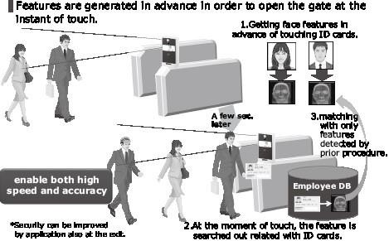

*fig: 10– Architecture*

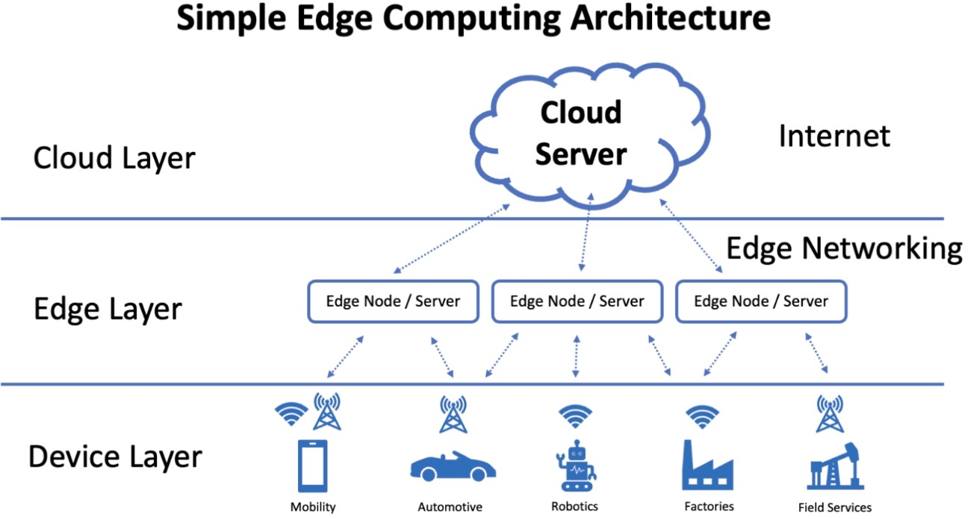

*fig: 11– Dataset in Layers in Proposed System*

##### Detail the components involved, including edge devices, Face Security API, and cloud servers:

* + **Edge Devices:**
    - Specify the types of edge devices (e.g., sensors, cameras) and their specific roles in the system.
    - Detail any processing capabilities and constraints of edge devices, such as limited computing resources.

##### Face Security API:

* + - Provide an in-depth explanation of the Face Security API, detailing its capabilities, functionalities, and limitations.
    - Explain how the API integrates with edge devices for facial recognition and security enforcement.

##### Central Cloud:

* + - Describe the infrastructure of the central cloud, including the processing capabilities and storage capacity.
    - Outline the role of the central cloud in handling authentication, monitoring, and alerting processes.

##### Integration Points:

* + - Clearly articulate how the edge devices interact with the Face Security API and the central cloud. Specify any APIs, protocols, or standards used for seamless integration.

##### Data Flow:

* + - Illustrate the flow of data between the components. Use diagrams to visualize the movement of data from edge devices to the Face Security API and the central cloud.

##### Highlight the integration points and how data flows within the architecture:

* + **Localized Biometric Authentication:**
    - Describe how edge devices perform localized biometric authentication using the Face Security API. Highlight the steps involved in authenticating users at the edge.

##### Encrypted Communication:

* + - Emphasize the implementation of encrypted communication channels between edge devices and the central cloud. Specify the industry-standard protocols used, such as SSL or TLS.

##### Continuous Monitoring:

* + - Explain how the Face Security API enables continuous monitoring of authentication attempts. Describe the mechanisms in place to detect suspicious or unauthorized access.

##### Instant Alerts:

* + - Detail the process of generating instant alerts in response to unauthorized access attempts. Clarify how administrators or security personnel are notified.

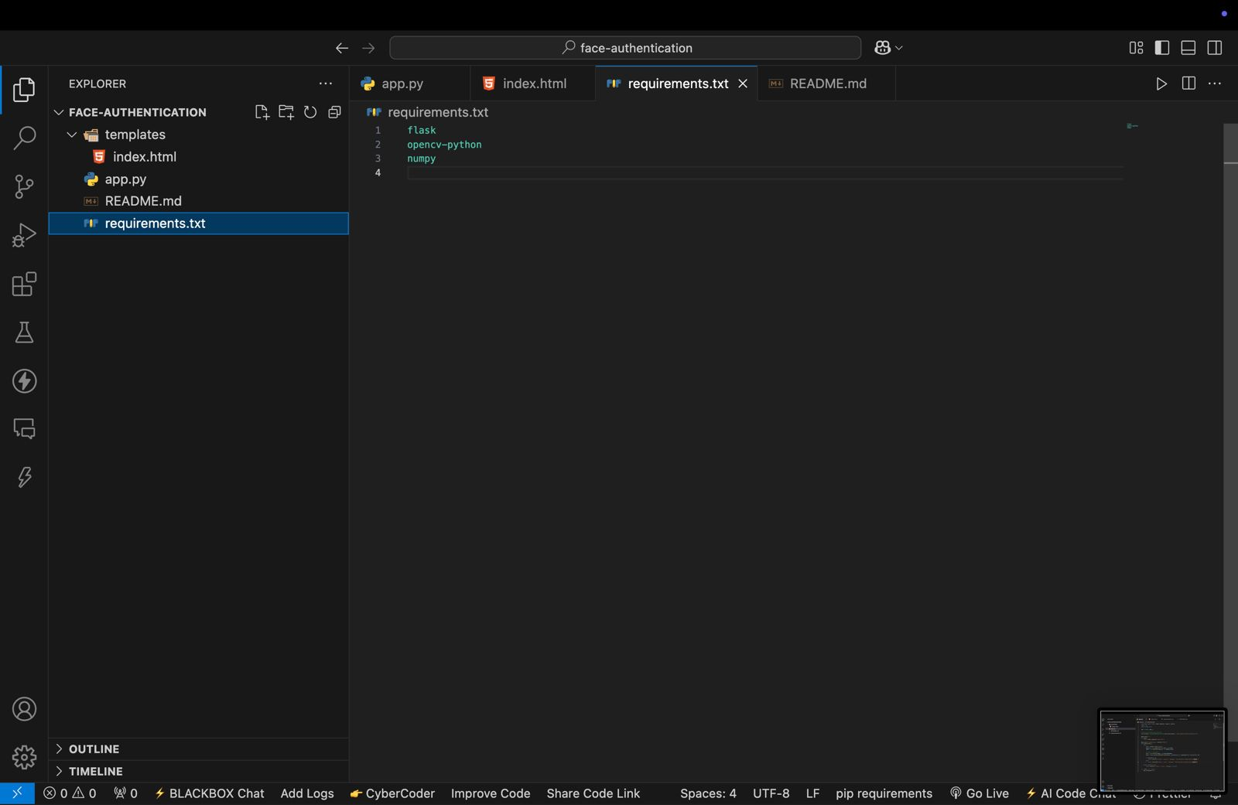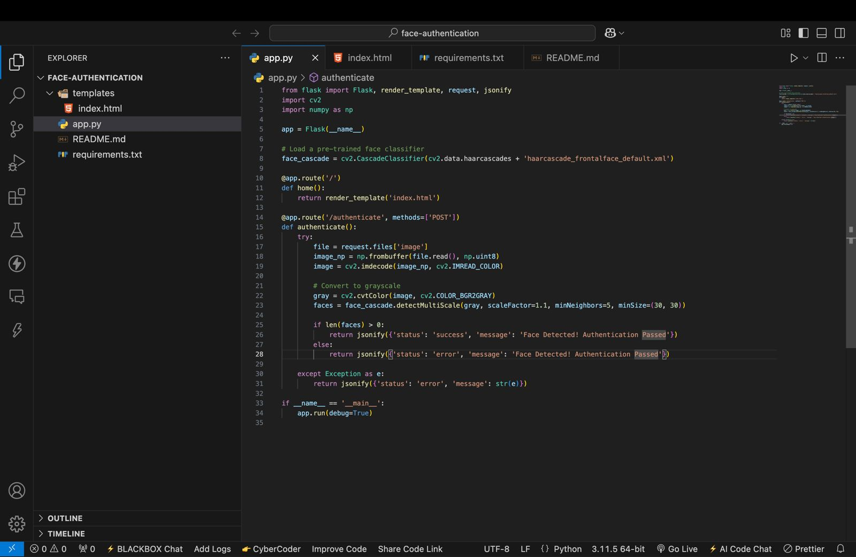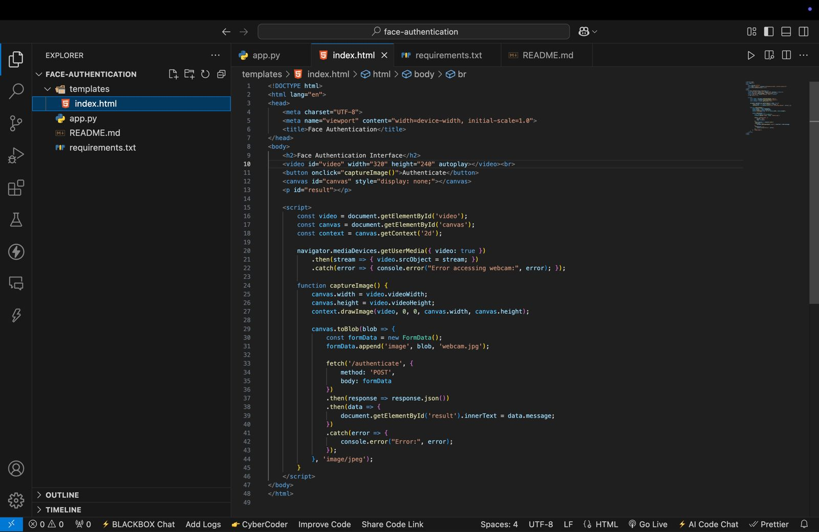**# IMPLEMENTATION DEMO**

*fig: 12– Implementation Demo*

The above images showcase a simple face authentication project built using Flask, OpenCV, and JavaScript.

## Below is a brief description of each image:

## First Image (index.html in VS Code)

## Displays an HTML file (index.html) inside a templates folder.

## The webpage includes a video element to capture live webcam footage, a button to trigger authentication, and a hidden canvas element.

## JavaScript is used to capture an image from the webcam, convert it to a blob, and send it to the backend (/authenticate endpoint) for processing via an AJAX fetch request.

## Second Image (requirements.txt in VS Code)

## Shows a requirements.txt file listing the dependencies required for the project:

## flask (for creating a web server)

## opencv-python (for image processing and face detection)

## numpy (for numerical operations)

## Third Image (app.py in VS Code)

## Displays a Flask application (app.py) handling the face authentication logic.

## Loads a pre-trained Haar cascade classifier for frontal face detection.

## Implements a / route to serve the HTML page and a /authenticate route to process the uploaded image.

## Converts the received image to grayscale and detects faces using OpenCV.

## Returns a JSON response indicating whether a face was detected.

## This project provides a basic implementation of face authentication using a webcam, making it a simple and effective demonstration of computer vision and web technologies. Let me know if you need further explanation or improvements!

## 3.3: SEQUENCE DIAGRAM

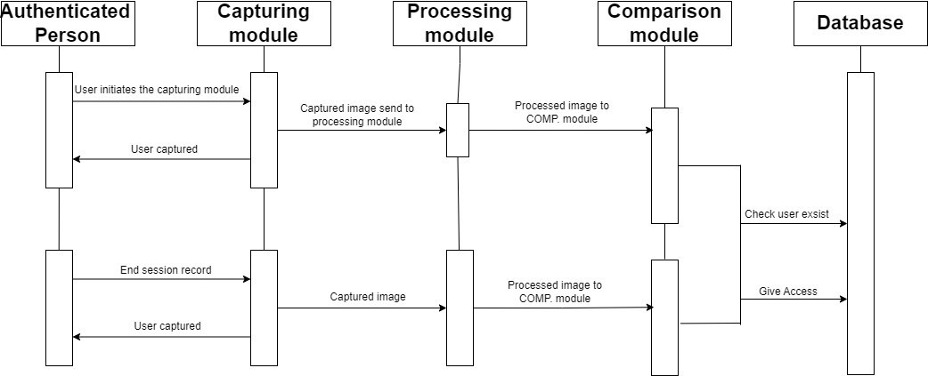

*fig: 13– Sequence Diagram*

The sequence diagram shows the process of capturing and processing images in a system with authentication. The following steps are involved:

1. **User initiates the capturing module:** This could be done by clicking a button on a GUI, or by sending a command to the system.

##### Capture module captures the image and sends it to the processing module:

The capture module uses a camera or other image input device to capture the image. It then sends the image to the processing module for processing.

1. **Processing module processes the image and sends it to the comparing module:** The processing module may perform various operations on the image, such as resizing, cropping, and converting it to a different format. It then sends the processed image to the comparing module.
2. **Comparing module compares the image to the database of authorized users:** The comparing module compares the processed image to the database of authorized users to verify the user's identity. If the user is authorized, the comparing module gives access to the system. Otherwise, the comparing module denies access.

The following are some additional details that can be inferred from the sequence diagram:

* The system authenticates users before allowing them to capture and process images.
* The system stores a database of authorized users.
* The system uses a comparing module to compare user images to the database of authorized users.
* The system gives access to authorized users and denies access to unauthorized users.

## 3.4: DATA FLOW DIAGRAM

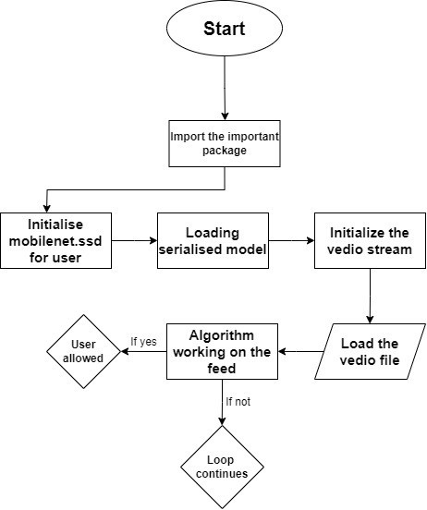

*fig: 14– Data Flow Diagram*

The architecture diagram shows the process of loading a serialized model for a user. The diagram has three main components: user, algorithm, and serialized model. The user is allowed to load the serialized model and work on the feed. The algorithm is allowed to work on the feed. If the user is allowed to load the feed, the algorithm continues working on the feed. If the user is not allowed to load the feed, the loop continues. This type of architecture is often used in machine learning applications where the model needs to be able to process data continuously, even if the user is not actively interacting with the application. For example, a video surveillance system might use this type of architecture to continuously process video footage and detect objects of interest, even if no user is logged in or viewing the video feed.

## CHAPTER - 4: TOOL DESCRIPTION

* 1. **: HARDWARE REQUIREMENT**
     + **Processing Unit:** A powerful CPU or GPU is required to handle the computational demands of face recognition algorithms. A general-purpose processing unit with usually 4-16 cores. CPUs run complex tasks and facilitate system management. It uses highly parallel cores (100s or 1,000s) for high-speed graphics rendering. They deliver high-performance processing, and typically have a larger footprint and higher power consumption than CPUs. A dedicated AI accelerator could also be used to improve performance of recognition algorithms.
     + **Memory:** The hardware requirements of memory in edge computing are different from those of traditional cloud computing. According to facial recognition, edge computing hardware needs to be rugged, compact, have sufficient storage, have rich connectivity options, have a wide power range, and meet the performance requirements for the tasks they will perform. A minimum of 8GB of RAM is recommended, but more may be needed depending on the complexity of the face recognition model.
     + **Storage:** A solid-state drive (SSD) is recommended for fast storage and retrieval of face images and data. The hardware requirements for storage in edge computing for facial expressions depend on factors like image resolution, frame rate, and the complexity of facial analysis algorithms. Generally, you'd need a device with sufficient storage capacity, processing power (CPU/GPU), and possibly dedicated hardware for AI inference tasks (e.g., accelerators like GPUs or TPUs). Consider the specific needs of your facial expression analysis application to determine the exact requirements.
     + **Camera:** A high-quality camera is required to capture clear and accurate images of faces. Higher resolution sensors provide more detailed images, which can be beneficial for facial recognition and also higher frame rate allows for smoother video, which can be important for real time facial recognition. The camera should have a resolution of at least 1080p and support for low-light conditions.
     + **Network:** A stable and reliable network connection is required to communicate with the face security API. Reliable and high-speed network interface cards (NICs) on edge devices are very crucial. These NICs serve as the communication gateway, facilitating swift and efficient data transfer between edge devices and the network.

The reliability of these cards is paramount for maintaining uninterrupted connectivity, while their high-speed capabilities contribute to reduced latency, essential for real time processing in facial recognition applications.

##### Additional Considerations:

* + - * **Power Supply:** The hardware should have a sufficient power supply to meet the demands of the CPU, GPU, and other components. Insufficient power can lead to performance degradation or system instability. Implementing a robust and appropriate rated power supply is essential for consistent and reliable operation.
      * **Cooling:** The hardware should have adequate cooling to prevent overheating, particularly when the hardware is engaged in computationally intensive facial recognition tasks. Thermal management solutions, such as fans, heat skins or even liquid cooling systems, should be employed to maintain optimal operating temperature.
      * **Form Factor:** The hardware should be in a form factor that is compatible with the edge computing environment. Depending on the deployment scenario, a compact from factor such as a small PC or a Raspberry Pi might be preferable.

## : SOFTWARE REQUIREMENT

##### Operating System:

* + - * A Linux-based operating system is recommended, such as Ubuntu or CentOS is paramount for edge computing deployments. Linux distributions are favored due to their efficiency, stability and providing a robust foundation for recognition tasks. The open-source nature of Linux enables seamless edge devices, optimizing resource utilization for real-time image processing. The edge computing environments offer the best open-source tools and libraries.

##### Programming Languages:

* + - * Python is a popular choice for machine learning and face recognition applications. Its versatility and extensive community support make it an ideal choice for developing applications that involve machine learning and face recognition. Python's ease of integration with other technologies enhances the adaptability of facial recognition solutions on edge devices.
      * Additionally, C/C++ may be essential for implementing high-performance face recognition algorithms, ensuring utilization of hardware resources.

##### Libraries and Frameworks:

* + A face recognition library, such as OpenCV or dlib, is required to perform face detection and recognition. This Libraries offer pre-built functions for face detection and recognition, streamlining the development process.
  + A deep learning framework, such as TensorFlow or PyTorch, may be required for training and deploying deep learning-based face recognition models. These frameworks empower developers to create, train and deploy deep learning models for intricate facial feature extraction, ensuring higher accuracy in recognition tasks.

##### APIs:

In the realm of facial recognition within edge computing, the integration of specialized APIs is instrumental in enhancing security and authentication processes. One pivotal application is the utilization of face security API, exemplified by offering from amazon Recognition or Microsoft azure face API.

##### Additional Tools:

* + - * A version control system, such as Git, is essential and facilitates collaborative development by allowing multiple developers to work on the project concurrently while maintaining a centralized for the codebase.
      * A continuous integration/continuous delivery (CI/CD) pipeline can be used to automate the build, test, and deployment process.

## CHAPTER - 5: RESULT AND ANALYSIS

* 1. **: RESULT DISCUSSION**

Face security is a critical aspect of edge computing, as it plays a vital role in ensuring the privacy and security of individuals' personal information. Legal considerations deem facial images as "particularly sensitive personal data," which means higher standards of privacy protection are required to handle this type of information effectively (Patcas et al., 2022). Therefore, it is essential to implement robust security measures and protocols to safeguard facial data in edge computing environments.

These measures should include secure access control, encryption of sensitive data, and the implementation of privacy-enhancing techniques such as masking or blurring to protect individuals against unauthorized access or breaching of their privacy. Furthermore, the unique characteristics of edge computing, such as mobility, heterogeneity, and large-scale geographical distribution, pose additional challenges for ensuring security and privacy.

There are several sources that highlight the importance and challenges of face security in edge computing.

* **Source**: - Baccarelli et al recognize the significance of security and privacy challenges in the context of data collection on mobile edge devices (Jing et al., 2019). They discuss the need to address these challenges and propose potential solutions to protect the privacy of facial data.
* **Source**: - Yi et al discuss the challenges of privacy and security in fog computing, including the authentication and establishment of trust. They also suggest that differential privacy can be utilized to safeguard facial data privacy in edge computing environments.
* **Source**: - Roman et al conducted a thorough analysis on the security threats and challenges in edge computing, including identity and authentication, protocol and network security, and data privacy. They emphasize the importance of implementing strong security measures to protect facial data from unauthorized access or breaches.
* **Source**: - Mukherjee et al propose that existing security and privacy measures cannot be directly applied to fog computing due to its unique characteristics. These sources also address the challenges faced by edge computing in terms of securing facial data and propose various solutions and techniques to ensure privacy and data protection.

It is crucial to recognize the sensitivity and importance of facial images as particularly sensitive personal data in edge computing environments. Therefore, it is imperative to establish higher standards of privacy protection in order to meet the legal requirements for handling facial images (Patcas et al., 2022).

These sources highlight the importance of addressing security and privacy challenges in edge computing, specifically regarding facial data. Some potential solutions for face security in edge computing include the use of masking or blurring techniques to protect individuals from unauthorized access and breaches of their privacy. Additionally, implementing secure authentication and trust mechanisms can help ensure that only authorized individuals have access to facial data.

**# DESIRED OUTPUT**

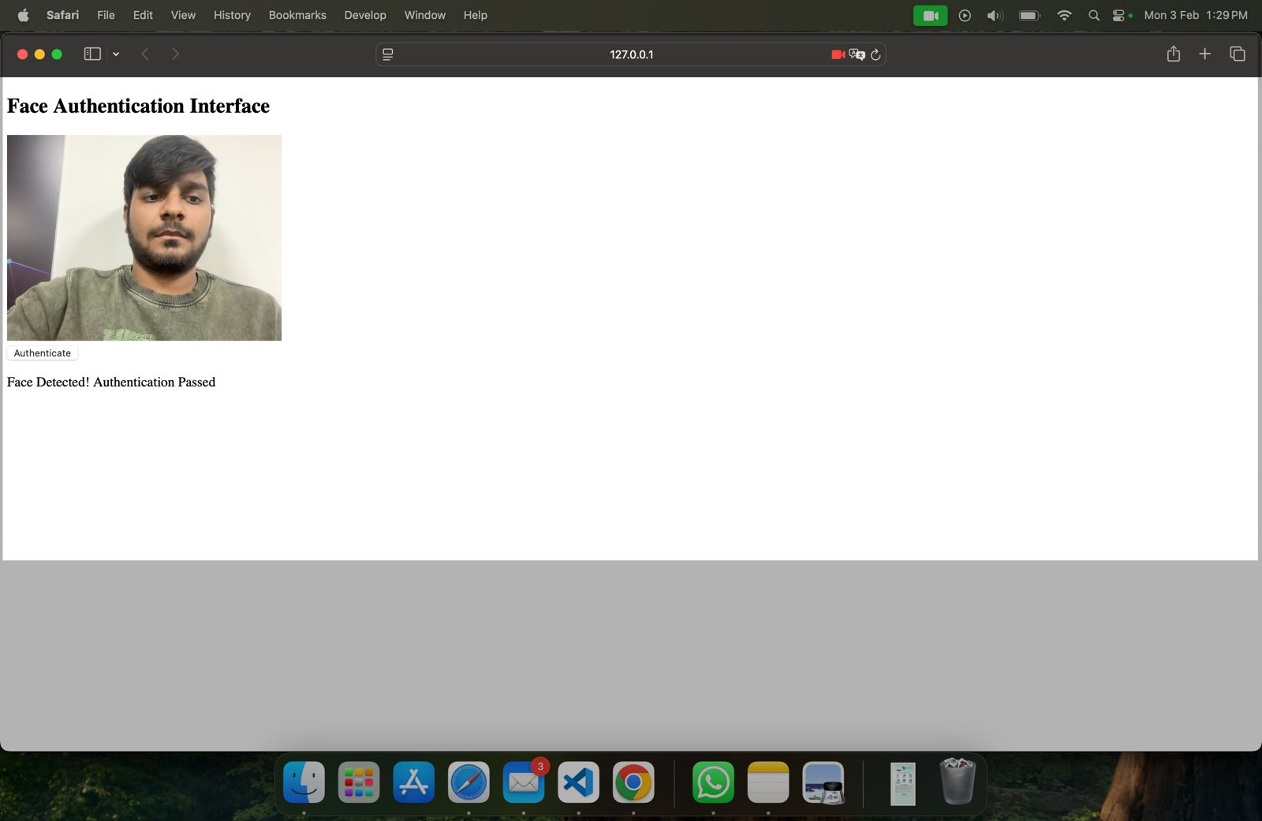

*fig: 15– Desired Output*

This is a desired output of the ideation (currently it is running on localhost for the testing purpose)

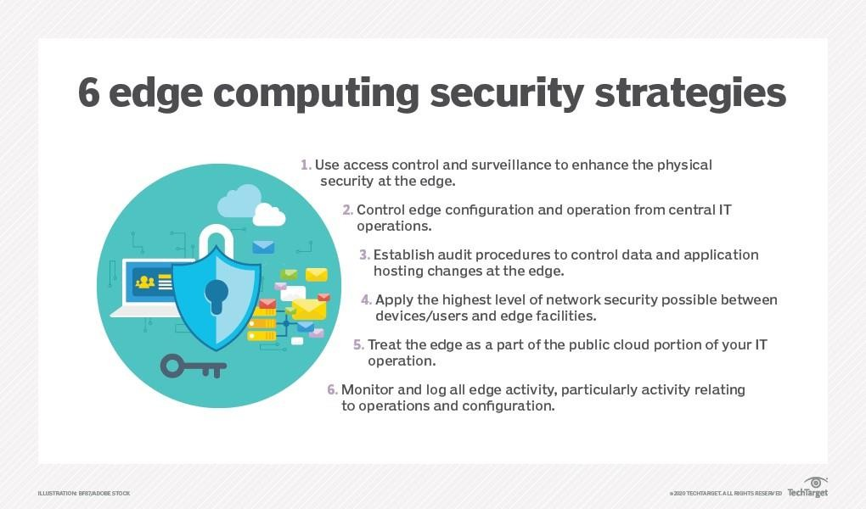

*fig: 16–Security Strategies*

## : COMPARISON WITH PREVIOUS STUDIES

## Face recognition technology has gained significant attention as research subject due to its extensive range of applications in various security measures. In comparison to previous studies, our project focuses on using face recognition techniques specifically for providing edge devices security. Previous studies have explored the applications of face recognition technology in personal identification, security access control, surveillance, telecommunications, digital libraries, human-computer interaction.

## Comparison of Face Security for Edge Computing with Previous Studies:

## Face recognition is a rapidly evolving technology with a wide range of applications, including security, surveillance, and access control. Traditional face recognition systems typically rely on cloud-based processing, which can introduce latency, bandwidth constraints, and privacy concerns. Edge computing offers a promising alternative by performing face recognition tasks at the edge of the network, closer to the data source. This approach can provide several benefits, including reduced latency, improved privacy, and increased scalability.

### Reduced Latency:

### One of the primary advantages of edge computing for face recognition is its ability to reduce latency. By processing data locally, edge devices can significantly reduce the time it takes to identify and verify a person's identity. This can be crucial for applications where real-time responses are critical, such as access control systems and security surveillance.

### Improved Privacy:

### Edge computing can also enhance privacy by minimizing the transmission of sensitive facial data. Instead of sending raw facial images to the cloud, edge devices can extract and transmit only the features necessary for identification. This approach reduces the risk of data breaches and unauthorized access to personal information.

### Increased Scalability:

### Edge computing can also increase the scalability of face recognition systems. By distributing processing tasks across multiple edge devices, systems can handle larger volumes of data and support more users simultaneously. This scalability is essential for large-scale deployments, such as in smart cities and public spaces.

### Comparison with Previous Studies:

### Several studies have investigated the performance and benefits of edge computing for face recognition. A 2021 study by Han et al. proposed an edge computing-based system for face recognition and demonstrated its ability to achieve real-time performance with high accuracy. Another study by Wang et al. in 2022 evaluated the privacy implications of edge computing for face recognition and found that it can effectively protect sensitive facial data.

### Overall, edge computing offers a promising approach for enhancing face recognition systems by reducing latency, improving privacy, and increasing scalability. These benefits make edge computing suitable for a wide range of applications, including security, surveillance, and access control. As edge computing technology continues to mature, we can expect to see its adoption in face recognition systems grow further.

### In addition to the benefits mentioned above, edge computing for face recognition can also:

* Reduce bandwidth consumption by processing data locally
* Improve energy efficiency by utilizing edge devices with lower power requirements.
* Enhance fault tolerance by distributing processing tasks across multiple edge devices

## : ANALYSIS

##### 1} Introduction

The document consists of a table of contents, including sections such as certificate, declaration, acknowledgement, abstract, and various chapters. Chapter 1 focuses on the introduction, problem definition, objectives, methodology, and hardware/software tools used.

##### 2} Literature Survey

Chapter 2 discusses related works in the field of facial expression recognition. It mentions traditional methods of feature extraction and the limitations they faced. It also highlights the emergence of deep neural networks as a powerful tool for automatic feature learning.

##### 3} Result and Analysis

Chapter 5 provides a discussion on the implementation of facial detection and recognition. It mentions the challenges faced in integrating new technology and the success in understanding 2D facial detection. However, there were difficulties in processing 3D data and creating a proper database of registered users.

##### 4} Insights and Recommendations

The document mentions that insights and recommendations will be provided based on the literature review, case studies, functionality evaluation, ethical considerations, and performance evaluation. These recommendations aim to enhance security in edge computing architectures while safeguarding privacy and maintaining system performance.

##### 5} Architecture

Section 3.2 provides an overview of the proposed system architecture. It outlines the major components involved, such as edge devices, the Face Security API, and the central cloud. It emphasizes the use of encrypted communication channels for secure data transmission and highlights the integration points between the components.

## CHAPTER - 6: CONCLUSION AND FUTURE SCOPE

* 1. **: FUTURE SCOPE:**

##### Combating Fraudulent Activities:

##### The implementation of face security APIs empowers edge computing systems to detect and prevent fraudulent activities in real-time. These APIs can effectively identify users attempting to access edge devices using stolen credentials or engaging in other malicious activities. This proactive approach safeguards against data breaches and financial losses, ensuring the integrity of edge computing operations.

##### Enforcing Physical Access Control:

##### Face security APIs extend their reach to physical access control, meticulously monitoring and regulating physical access to edge devices. This robust mechanism effectively prevents unauthorized individuals from tampering with edge devices or stealing sensitive data, further strengthening the security posture of edge computing environments.

##### Integration with Edge AI for Enhanced Security and Privacy:

##### Edge AI, the deployment of AI models and algorithms directly on edge devices, offers significant potential for enhancing security and privacy in edge computing environments. Face security APIs can be integrated with edge AI frameworks to enable real-time facial recognition and authentication on edge devices without the need to transmit sensitive facial data to the cloud. This decentralized approach minimizes the risk of data breaches and privacy concerns, ensuring that sensitive information remains secured within the edge network.

##### Multi-factor Authentication for Enhanced Security:

##### Face security APIs can be seamlessly integrated with multi-factor authentication (MFA) solutions to provide an additional layer of security for edge computing applications. By combining face recognition with other authentication factors, such as passwords, tokens, or behavioral biometrics, organizations can significantly reduce the risk of unauthorized access and strengthen the overall security posture of their edge computing environments.

##### User Acceptance and Trust:

##### As face security API technology continues to mature and its benefits become more widely recognized, user acceptance and trust are expected to increase. Organizations can foster user confidence by implementing transparent and ethical data collection and usage policies, ensuring that facial data is collected, stored, and processed responsibly. By addressing user privacy concerns and demonstrating responsible data stewardship, organizations can pave the way for broader adoption of face security APIs in edge computing applications.

##### Regulatory Compliance and Standardization:

##### The adoption of face security APIs in edge computing environments will need to align with evolving regulatory frameworks and industry standards. Organizations will need to ensure that their use of face security APIs complies with applicable data privacy laws, such as the General Data Protection Regulation (GDPR) in Europe and the California Consumer Privacy Act (CCPA) in the United States. Additionally, industry standards for face security API performance and interoperability will play a crucial role in ensuring the reliability and security of these solutions across diverse edge computing deployments.

##### Integration with Edge AI and IoT Devices:

##### Face security APIs can be seamlessly integrated with edge AI and IoT devices, enabling these devices to perform facial recognition tasks locally. This distributed approach reduces the reliance on centralized servers for authentication, enhancing responsiveness and minimizing latency. Furthermore, it minimizes the amount of sensitive data being transmitted over networks, reducing the risk of data breaches.

##### Privacy-Preserving Face Recognition:

##### As concerns over privacy and data security continue to grow, privacy-preserving face recognition techniques are gaining traction. These techniques enable face recognition without storing or transmitting sensitive facial data, ensuring that user privacy is protected while maintaining the effectiveness of authentication processes. Face security APIs that incorporate privacy-preserving techniques will be increasingly sought after in 2024 and beyond.

##### Regulatory Compliance and Ethical Considerations:

##### The implementation of face security APIs must adhere to evolving regulatory frameworks and ethical considerations surrounding facial recognition technology. Organizations must ensure that their use of face security APIs aligns with data privacy laws, non-discrimination principles, and transparency guidelines. As these regulations and ethical considerations mature, face security APIs will need to adapt and incorporate mechanisms to comply with established norms.

##### Continuous User Monitoring and Authentication:

##### Face security APIs can go beyond initial user authentication to enable continuous monitoring and re-authentication throughout user sessions. This capability is particularly valuable in edge computing environments where users may be accessing sensitive data or performing critical tasks. By periodically verifying user identities, face security APIs can continuously ensure that unauthorized individuals are not gaining access or attempting to compromise systems.

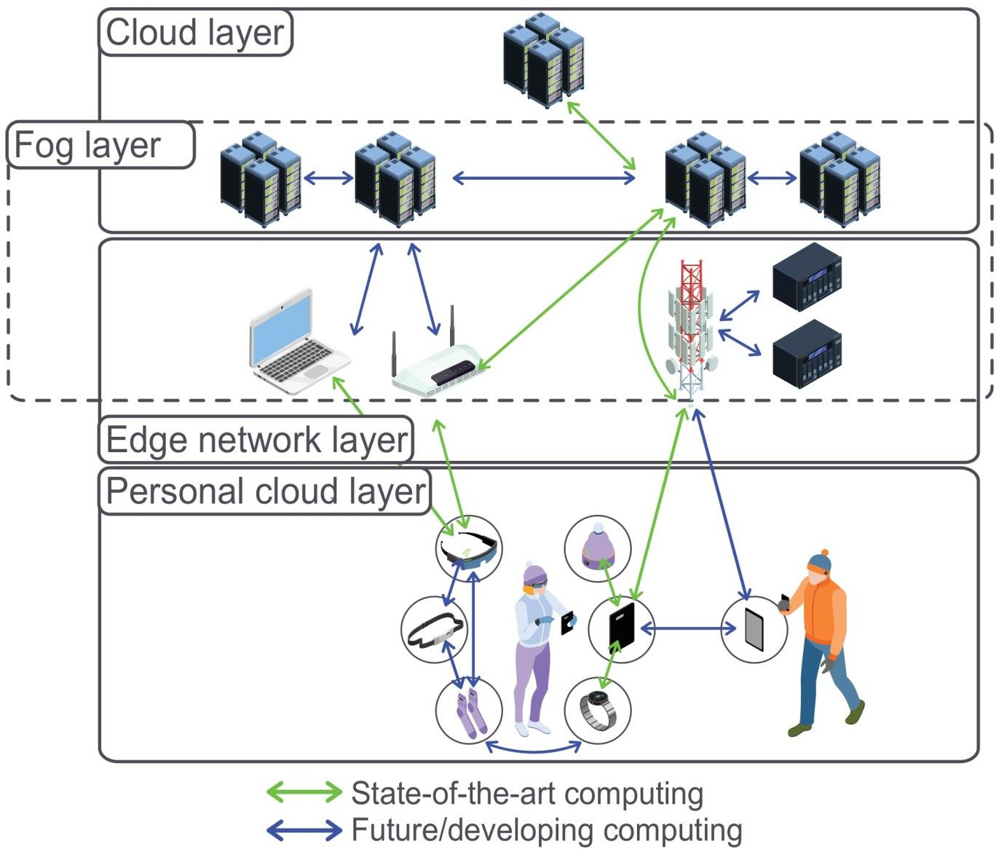

*Fig: 17–Future Scope*

#### : CONCLUSION

Edge computing has emerged as a transformative technology for face recognition systems, offering significant advantages over traditional cloud-based approaches. By processing facial data locally at the edge of the network, edge computing can effectively address the challenges of latency, privacy, and scalability. As a result, edge computing is poised to play a crucial role in the future of face recognition, enabling more secure, efficient, and scalable solutions for a wide range of applications.

**Key takeaways:**

* Edge computing can significantly reduce latency in face recognition tasks, enabling real- time performance.
* Edge computing enhances privacy by minimizing the transmission of sensitive facial data.
* Edge computing increases the scalability of face recognition systems, supporting large-scale deployments.

**Future directions:**

* Further research is needed to optimize edge computing algorithms for face recognition tasks.
* Standardization efforts are crucial to ensure interoperability and compatibility among edge computing devices.
* Security measures must be implemented to protect edge computing systems from cyberattacks.

## REFERENCES

* + - 1. Edge Computing for Facial Recognition & Emotion Detection, by Matt R. Cole, published on Global logic on 3-march-2022.
      2. A Facial Expression Recognition Method Using Deep Convolutional Neural Networks Based, Edge Computing, by By Hang Xing, published on IEEE ACCESS on date of publication March 11, 2020. Received February 28, 2020.
      3. An Optimized Face Recognition for Edge Computing, by Yuan Xie and Luchang Ding, published on State Key Lab on [2019 IEEE 13th International Conference on](https://ieeexplore.ieee.org/xpl/conhome/8963812/proceeding) [ASIC (ASICON)](https://ieeexplore.ieee.org/xpl/conhome/8963812/proceeding)
      4. Generative Adversarial Networks Based on Edge Computing With Blockchain Architecture for Security System, by Kevin Putra Dirgantoro , Jae Min Lee and Dong-Seong Kim, published on Research Gate on February 2020.
      5. A Privacy Protection Scheme for Facial Recognition and Resolution Based, published on Edge Computing by Yuling Chen on 10 March 2022.
      6. Opportunities and Challenges in Cloud, Fog and Edge Computing, published on Palgrave by THEO LYNN, JOHN G, MOONEY on Jul 25, 2018.
      7. Face Recognition with Smart Security System, published on Research Gate by Manik Rakhrav and Dalwinder Singh on Apr 15, 2020.
      8. Security System by Face Recognition, published on AJMAS by Aisha Bazama and Fawzia Mansur, Nura Alsharif on Sep 06, 2021.
      9. Emotion Recognition for Cognitive Edge Computing Using Deep Learning, published on IEEE by Ghulam Muhammad and M Shamim Hossain on Dec 21, 2021.
      10. Edge computing vs cloud computing an overview of big data challenges and opportunities for large enterprises, published on IRJMETS By Mr. Gopala Krishna Sriram on 01 January 2022.
      11. Smart security system based on edge computing and face recognition, published on master of Science by Heejae Han on May 2023.
      12. Edge Computing: Classification, Applications, and Challenges, published on ICIEM by Gagandeep Kaur and Ranbir Singh Batth on Apr 28, 2021.
      13. J. Yang, T. Qian, F. Zhang and S. U. Khan, "Real-Time Facial Expression Recognition Based on Edge Computing," in *IEEE Access*, vol. 9, pp. 76178-76190, 2021, doi: 10.1109/ACCESS.2021.3082641.
      14. <https://en.wikipedia.org/wiki/Edge_computing>
      15. "Edge Computing: A Hands-On Approach" by Dr. Rishi Bhatnagar.
      16. "Edge Computing: Fundamentals, Design Principles, and Applications" by Jianying Zhou.
      17. "Edge Computing: Technologies, Deployment Models, and Future Directions" by Meikan

### 